**Demographics and Psychographics**

Demographics:

* Males and females
* Age 17-25
* 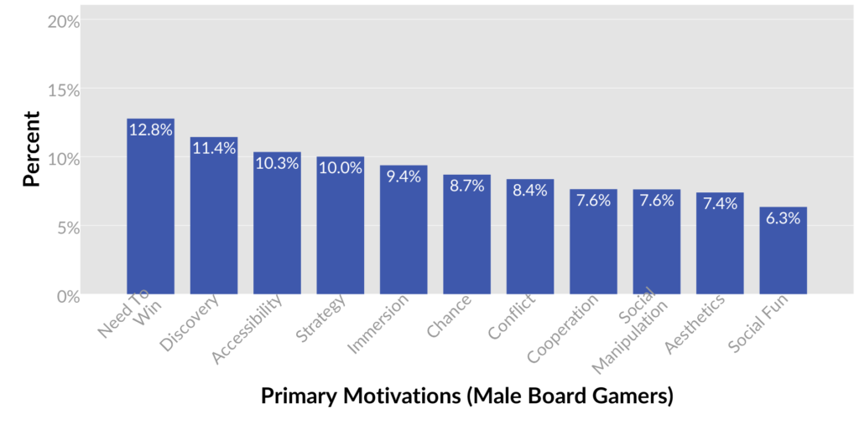Casual
* Males enjoy strategy in games
* Conflict and co-operation
* Social manipulation

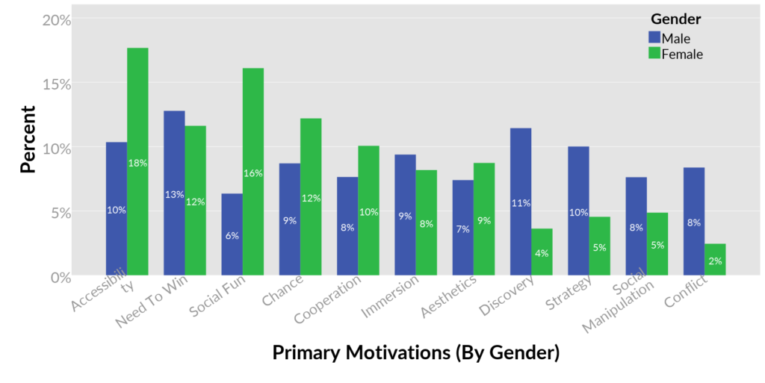

* Accessibility is important to both genders
* Since females prefer cooperation and males prefer conflict, we want to create opportunities for both types of play to arise. In a voting game people may team up against others, etc
* 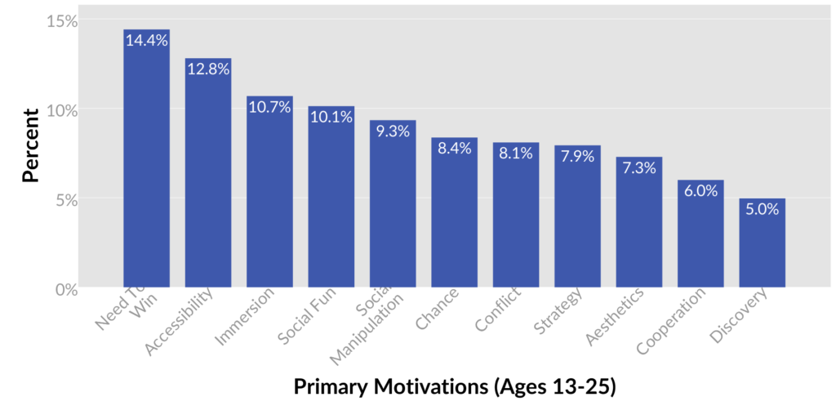Social fun – voting games often involve a lot of discussion
* Accessibility – players within this age range prefer games that are easy to learn and easily accessible to newcomers
* Social manipulation – voting games allow for bluffing, persuasion, deception, negotiation, etc
* Chance and strategy are nearly equal in terms of what players like to see in board games

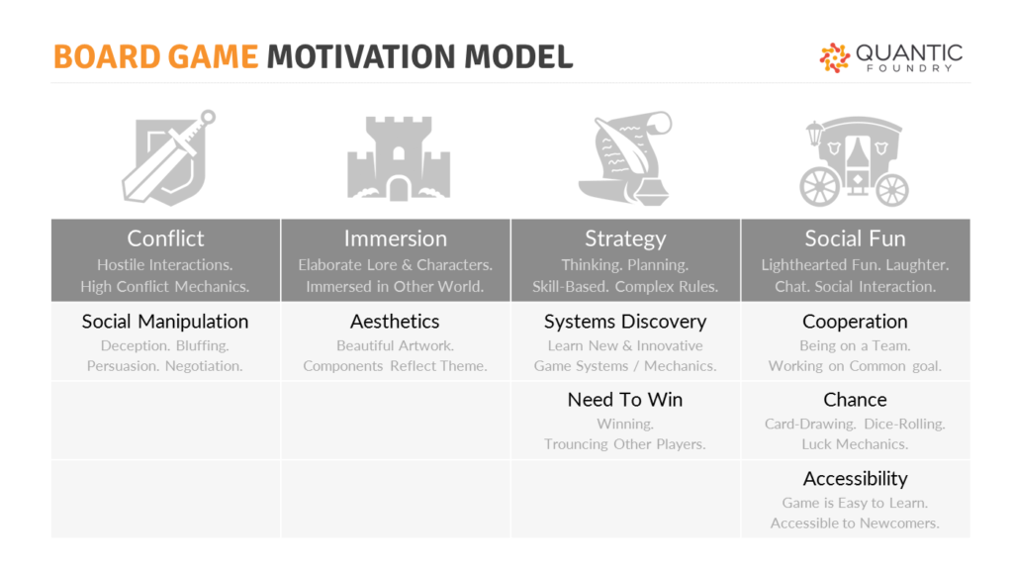

Psychographics:

Name: George

Gender: Male

Age: 23

* Lives in Norwich
* Outgoing
* Lives with flatmate Ben, who also invites friends over fairly regularly
* Has a 9-5 job working in social media marketing

Hobbies/interests:

* Meeting up with friends – go to the pub, each other’s houses
* They have small gatherings at their flat with friends and often play games together – digital (Super Smash Bros) & non digital (once a week-ish)
* The pub they go to has a board game evening, he likes to use this as an opportunity to socialise with new people
* Uses Twitter, Facebook, Snapchat and Instagram
* Likes memes and often sends them in group chats with friends
* Watches Netflix instead of TV – Stranger Things, Riverdale, The Haunting of Hill House, American Horror Story, Brooklyn Nine-Nine
* Listens to progressive rock/metal
* Likes watching sports – meets up with friends to watch together